**AirTanker Wellbeing Services**

The following services are offered free to AirTanker Pilots, Sponsored Reservist (SR) and Civilian employees. **All services are subject to change.**

**Latus Occupational Health Services**

Occupational Health provides employers and employees with mental and physical health services to keep us healthy at work and offers the following services to AirTanker:

* **Line Manager Referrals**: in support of employee mental and physical health, return to work, and workplace adjustments.Staff are referred through HR or Line Manager.
* **Know Your Numbers (KYN) assessments**: Latus offer 15-minute physiologist one to one in person assessments where your height, weight, BMI, blood pressure, total/HDL ratio, blood glucose, resilience, and resting heart rate are tested. Assessments days are held at The Hub RAF Brize Norton. KYN days are promoted in advance and details are available via the Engage App. KYN’s are designed to help you make positive lifestyle changes, ensuring you stay fit and healthy.

**Employee Assistance Programme (EAP) - provided by UNUM Help@hand**

Unum Help@hand provides essential mental, physical and social essential services which include counselling, in support of mild to moderate difficulties, physiotherapy, 24/7 remote GP appointments, a 24/7 helpline [0808 304 3698](tel:0808%20304%203698), 1-2-1 lifestyle coaching, legal and financial support, and consumer savings and discounts. The service can be accessed direct by employees, without line manager or HR referral, and all calls and appointments are private and confidential.

To register, download the app, enter your work email address, select “Forgot Password” and enter your details. If you experience any difficulties registering, please inform [hr@uk.airtanker.co.uk](mailto:hr@uk.airtanker.co.uk). If you need support to make an appointment or use the app, please contact Help@hand via [Help-at-hand@squarehealth.com](mailto:Help-at-hand@squarehealth.com?subject=Help%40hand%20question) Or call the 24/7 helpline on [0808 304 3698](tel:0808%20304%203698).

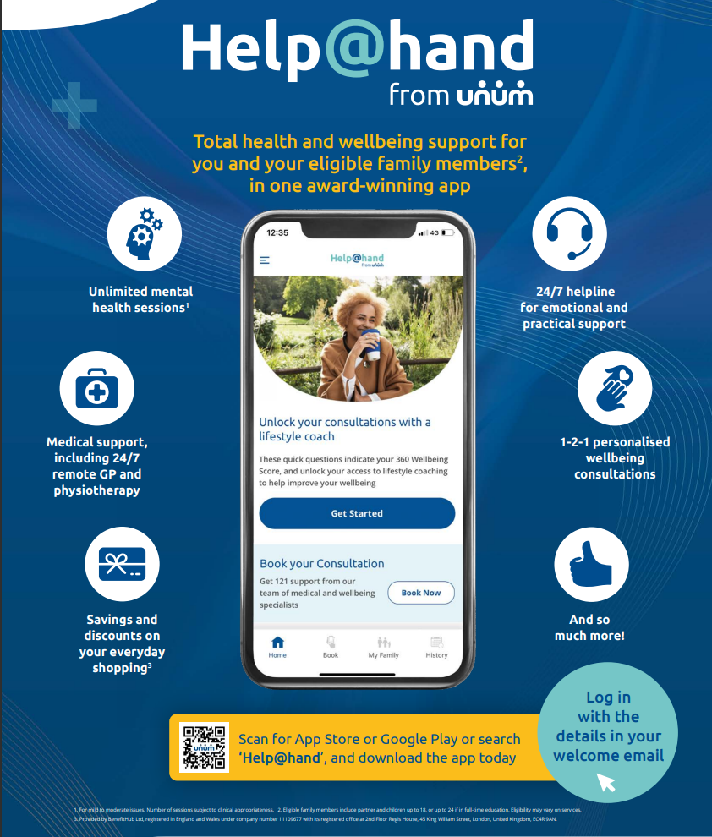

**Death in Service – provided by Unum**

Death in Service, also called Group Life Insurance, is a benefit which provides a lump sum payment to nominated beneficiary (ies) upon an employee’s death whilst working for AirTanker. The Insurance is provided by Unum and grants 4 times an employee’s basic annual salary. Personal details, including beneficiaries, should be kept updated in Select HR.

**Bippit – Financial Wellbeing**

AirTanker has partnered with Bippit to provide you with free 1-2-1 financial wellbeing coaching provided by FCA approved experts via the Bippit App. Simply scan the bar code and register for an account using your work email address.

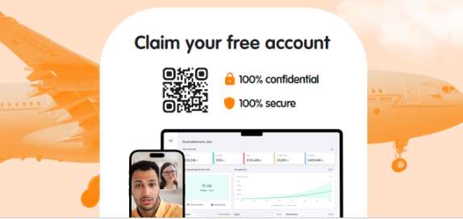

**EV – Electric Vehicle Salary Sacrifice**

AirTanker’s Electric Vehicle Salary Sacrifice Scheme, is designed to help you lease a brand new, fully maintained and insured, low emissions car. As a business, AirTanker are striving to reduce our impact on the planet and one way we can all do that is by switching to electric vehicles (EV). Please contact 03444632900 or corporatecustomerservice@novunavehiclesolutions.co.uk who will be able to help.

<https://www.novunacapitalcontrol.co.uk/cc/AirTankerServicesLimited>

**Cyclescheme**

The Cyclescheme enables you to purchase a bike for commuting to work and make payments through payroll with salary sacrifice. If you would like further information, please visit www.cyclescheme.co.uk or contact a member of the HR Team.

**Health Shield – health care cash plan.**

Covers everyday healthcare costs such as consumer discounts, Best Doctors (expert medical information & advice) dental treatments, optical bills, specialist consultations, diagnostic tests, PMI excess, complimentary & alternative therapies, chiropody, hospital stay, prescriptions, inoculations & flu jab and health screening.

Benefits table:

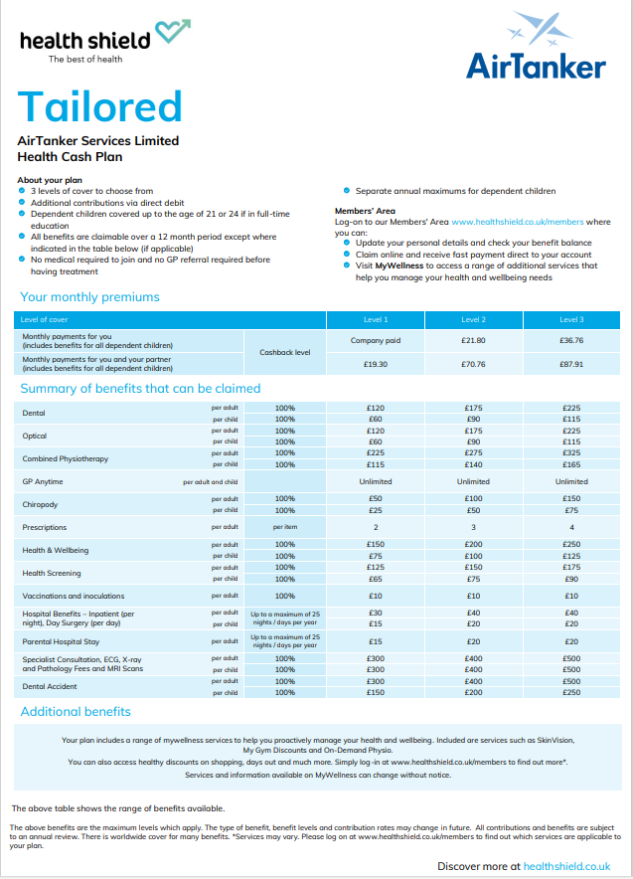

**Bupa** - **Private Medical Insurance**

In support of your health and wellbeing, AirTanker offers Private Medical Insurance, provided by Bupa, to **all**of our employees. Employees can take up single membership of our Private Medical Insurance scheme, which is paid for by the company, and add eligible dependants to their policy via monthly salary sacrifice deductions.

Bupa Private Medical Insurance covers the costs of private medical care, from diagnosis to treatment, and provides employees with quick access to medical treatment, subject to insurance policy underwriting.

Download the Bupa App, and register using your policy details, to access Bupa anytime HealthLine, Bupa Blua and many more health and wellbeing services. Whatever your health question or concern – from advice about symptoms, to information on leading a healthier lifestyle – you can speak to a nurse, 24 hours a day, seven days a week. You can ask us questions about anyone in your family, they don’t have to be on your policy.

Telephone numbers:

* Bupa Anytime HealthLine Call 0345 607 7777
* For all claims and cover enquiries call 0345 266 6051
* For elderly care advice Call 0330 134 6696
* Family Mental HealthLine Call 0345 2667938
* Menopause HealthLine Call 0345 6089984



**Headspace Meditation App**

Meditation has been shown to help people stress less, focus more and even sleep better. Headspace is meditation made simple and will teach you the life-changing skills of meditation and mindfulness in just a few minutes a day.

In support of your mental and physical wellbeing, AirTanker have partnered with Headspace to provide you and up to 5 family members, free subscription.

To register, all you have to do is follow these steps:

* Visit [https://work.headspace.com/airtanker/member-enroll](https://url.uk.m.mimecastprotect.com/s/HjOeCR8jLuKGpNMc9f4C12aJ2?domain=work.headspace.com)
* When prompted, choose “Yes, I have an account” since you have an existing Headspace account.
* Enter your eligible corporate info (email) - you will then receive a link to activate the subscription.
* Click the “Verify” button in the activation email to activate your new membership.

Please note: If you are unable to enroll using the steps above, please clear cache by following the steps [HERE](https://url.uk.m.mimecastprotect.com/s/qZm-CVJnNs42EMWszhGCEgxbP?domain=team.headspace.com)  
For more help following the steps above, please view the video tutorials below:

If you ***do*** have an existing account, please visit our [**Existing account enrollment process**](https://url.uk.m.mimecastprotect.com/s/pid5CWWo8tp6Q0MHKiPCoWR26?domain=team.headspace.com) tutorial.

Difficulty subscribing? Contact the Headspace Support Team at: [help@headspace.com](mailto:help@headspace.com) and for technical issues submit a ticket through the community site or email: [Teamsupport@headspace.com](mailto:Teamsupport@headspace.com)

**AirTanker People Team**

If you have a question for the People Team, please email [hr@uk.airtanker.co.uk](mailto:hr@uk.airtanker.co.uk) or speak to your People Partner, People Advisor, or Wellbeing & Inclusion Lead in support of confidential advice, guidance and support.

**RAF Brize Norton Support Services**

Eligible to Sponsored Reservists and Armed Forces Veterans (signposting services offered to civilians only)

1. Citizens Advice Bureau – [RAFBrizeNorton@citizensadvicewestoxon.org.uk](mailto:RAFBrizeNorton@citizensadvicewestoxon.org.uk)
2. RAF Brize Norton Chaplaincy – Clerk contact: 01993 896543
3. RAF Brize Norton Gymnasium (01993 897908) & Swimming Pool (01993 845128)
4. RAF Brize Norton Community Support –<https://www.raf.mod.uk/our-organisation/stations/raf-brize-norton/facilities/>
5. Military Charities – Eligible to Sponsored Reservists and Armed Forces Veteran/Retired
   1. SSAFA - [www.ssafa.org.uk](http://www.ssafa.org.uk)
   2. RAF Benevolent fund – [www.rafbf.org](http://www.rafbf.org)
   3. RAF Associations – [www.rafa.org.uk](http://www.rafa.org.uk)
   4. Combat stress – [www.combatstress.org.uk](http://www.combatstress.org.uk)
   5. Help for heroes – [www.helpforheroes.org.uk](http://www.helpforheroes.org.uk)
   6. RAF Families Federation – [www.raf-ff.org.uk](http://www.raf-ff.org.uk)
   7. Armed Forces Charities Directory - <https://armedforcescharities.org.uk/Public/Search_the_database/Public/Directory.aspx?hkey=23259e39-2b97-4644-b2f7-e05191b78bb9>